Tableau top tip
Saving your favourite reports and using tags

Numerous reports will be available to you within Tableau and functionality exists within the system to allow you to search reports to ensure you can easily identify the reports that are relevant to you. There are two ways to search reports; highlighting a report as a favourite and using tags to search for key words associated with a report.

Favourites
By highlighting a report as a favourite report Tableau allows you to gain quick access to these reports and not have to search through all of the available reports to find them each time you access the system.

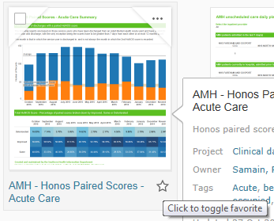
Making a report one of your favourites
When viewing the available reports click on the star icon of a report to identify it as one of your favourites; the star will then turn gold.

To remove the report from your favourites simply click on the star again and it will turn white.

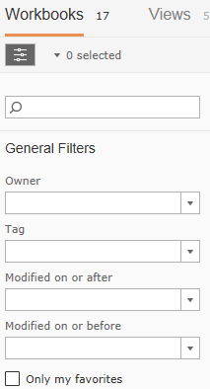
Viewing your favourites
To view your favourite reports either click the star icon in the black banner at the top of Tableau or tick the “Only my favourites” option in general filters, having gone into one of the Tableau projects (i.e. Clinical data).

Tags
Each Tableau report has tags assigned to it that allow you to search for reports with a specific tag. For example all reports relating to ISDs will have a tag of ISD applied to them, or reports with data taken from RiO will have a tag of RiO applied.

Access a project
Click into the project you wish to search within (i.e. Clinical data, HR data, Governance data).
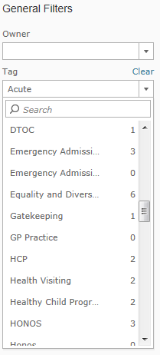
Select the tag you wish to search for
In the general filters option on the left hand side of the screen click the drop down labelled “Tag” and either click on the tag you wish to search for or type in the tag into the search box. Having done this the list of available reports will be filtered based upon your selected tag.

Clearing your tag search
If you wish to go back to the complete list of reports simply click the “Clear” option next to the Tag filter drop down.

