Tableau top tip
Exporting to EXCEL

We recognise that you may need to export a Tableau report to enable you to share it with other individuals within the organisation. Tableau allows you to export a table or the aggregate data behind a chart to Excel; enabling you to manipulate it in Excel to share with others or embed within other documents.

Important consideration when sharing exported data with other individuals
Please remember that within a number of Tableau reports there may be some element of patient identifiable data (Patient Name, Date of Birth, Age or NHS Number). When sharing exported Tableau data with others please ensure you do this securely in line with Trust guidance and, when PID is present, only send this from your NHS net account to other NHS net accounts.

To export the underlying data of a chart

Step 1: Click anywhere on your chart, ideally the white part of the chart

Step 2: Access the download menu
Click the download icon in the top right corner of the screen and click the Crosstab option

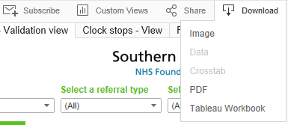

Step 3: Click Download and open in Excel
When prompted click ‘Download’ and the exported data will open in Excel.

To export the underlying data of a table

Step 1: Click on the Table
If you wish to limit the data to be exported highlight only data to be exported in blue by clicking on that part of the Table. Alternatively to export all data in the Table click on any header within the table.

In the example below only the data for Bordon and Petersfield CMHT will be exported because that section is highlighted below.

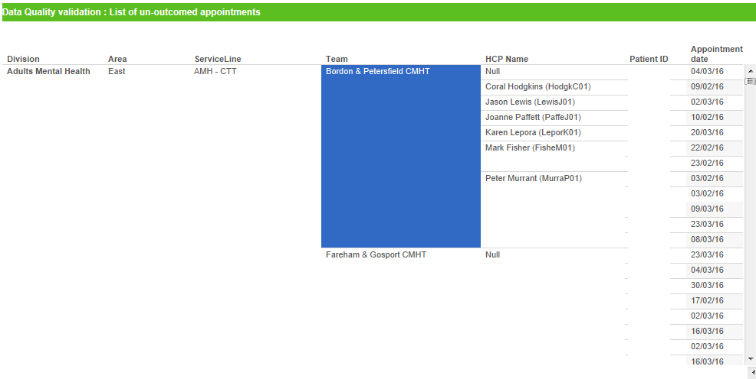

Step 2: Access the download menu
Click the download icon in the top right corner of the screen and click the Crosstab option

Step 3: Click Download and open in Excel
When prompted click ‘Download’ and the exported data will open in Excel.

