Visualisation style guide
Internal guidance for visualisation design – 100316
All Southern Health Tableau visualisations must have a consistent branding and style used to ensure consistency across visualisations and a positive user experience. This document outlines the standard style guide to be applied to all published visualisations via Tableau server.

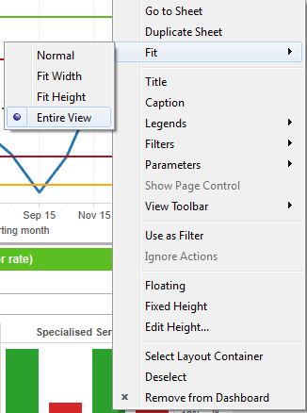
Dashboard layout and settings
Prior to creating any visualisations the following settings should be applied to your Dashboards:
- Tiled layout selected
- Dashboard size = Desktop (w 1000 h 800)
- Show title unticked
- Ideally when adding new charts and tables please apply the fit option of “Entire view” so the chart fills the available space.

Header
All visualisations must have a standard header, including the visualisation title and SHFT logo.
Visualisation header must be in font Arial Rounded MT Bold, size 14, left aligned using SHFT green
Trust logo in the right corner (use the cropped image), set the position to x 750 y 0 and the size to w 246 and h 69 with fit image clicked.

Footer
All visualisations must have a standard footer, including the visualisation version control and SHFT swirls.
Visualisation version control must be in font Calibri, size 10 non bold, left aligned, SHFT green colour applied. And must be in the following format and must be present on all views within the workbook.

Created and maintained by the Southern Health Information Department
Version Control : x.x dd/nmm/yyyy, Updated by
Trust swirls in the right corner right click image in Tableau and set the position to x 838 and y 722 and size 158 and h 78 with fit image clicked.

Filters and parameters
Filters common to the whole view should be placed at the top of the visualisation, under the footer.
Filters and parameters should have the title placed above the drop down and the font of the title set to Arial 9 with bold applied and left aligned. Utilise the SHFT green as the colour.

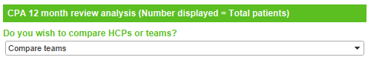
When a parameter of filter is required within the view, i.e. to apply to an individual chart apply the same font and style as above, title of the filter above the drop down with the font of the title set to Arial 9 with bold applied and left aligned. Utilise the SHFT green as the colour.

Chart and table titles
Each table or chart should have a title which is applied consistently across all titles as follows.
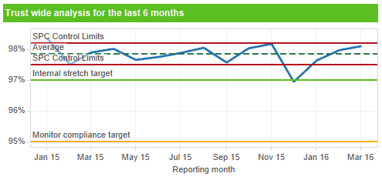
The title should be a text box with the background set to SHFT green and the font of the title set to Arial 9, bold, left aligned and colour white. The height of the text box should be set to the minimum height Tableau will allow, i.e. use the vertical resize arrow of the text box and drag it up until the box will not get any smaller.

Chart and table headers and labels
The labels of a chart or the header of a table should be consistently set to ensure a common look.
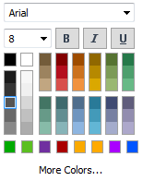
For charts set the date format to be as follows:

Monthly – mmm yy
Weekly – dd/mm/yy
Daily – dd/mm/yy

Font set to Arial 8, non bold and colour set to the 4th black option from the top:

Any table headers should have the follow styling applied.
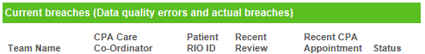
All table column headers should have the font set to Arial 8, non bold and colour set to the 4th black option from the top (same as above)

Colour legends
When a chart or table has conditional format or RAG rating applied to it the colours should be explained in a legend that is formatted as follows:
The title of the colour legend should be above the colours and font set to Arial 9, bold, left aligned using SHFT green colour.

SPC charts
All SPC charts should utilise the following look and labels:
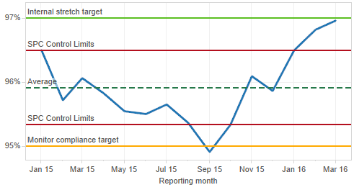
Control limits set as a solid line with red colour selected that is second from the top in the red to orange colour column of the available colour options. Apply a label to the control limits of “SPC Control Limits”.

The average should be a dotted line (1st dotted option, not 2nd) with the green applied as the top green option in the green column of the available colours, apply a label of “Average”.

If any targets need to be applied use the SHFT green for the colour of compliance or stretch (i.e. Green target) and the SHFT orange for the colour of the amber. Apply labels depending on the target type i.e.

“Internal stretch target” or “Compliance target” = Green line
“Internal tolerance” or “Monitor compliance target” = Amber line

Visualisation colour palettes
The following colour palettes are to be used in published visualisations:

Colour | Pantone | Red | Green | Blue | Reports applied to
Pink | 212 | 249 | 79 | 142 | Patient experience
Light Green | 368 | 91 | 191 | 33 | Clinical
Purple | 526 | 104 | 33 | 122 | Workforce and LEaD
Blue | 631 | 84 | 183 | 198 | Governance
Orange | 1375 | 249 | 155 | 12 | i reports

The column “Reports applied to” refers to which colour to use for the font and title boxes as referenced in this document, i.e. when developing a governance report you would use the blue colour to apply to the fonts and title boxes as opposed to green.

Red Amber Green KPI colour palettes
The following colours should be used when applying a colour to a box, text or chart for a RAG rating:

Red = Tableau 10 colour palette, red option selected
Amber = Tableau 10 colour palette, orange option selected
Green = Tableau 10 colour palette, green option selected

Summarised example
SHFT logo top right and fixed height and size set to fill all.
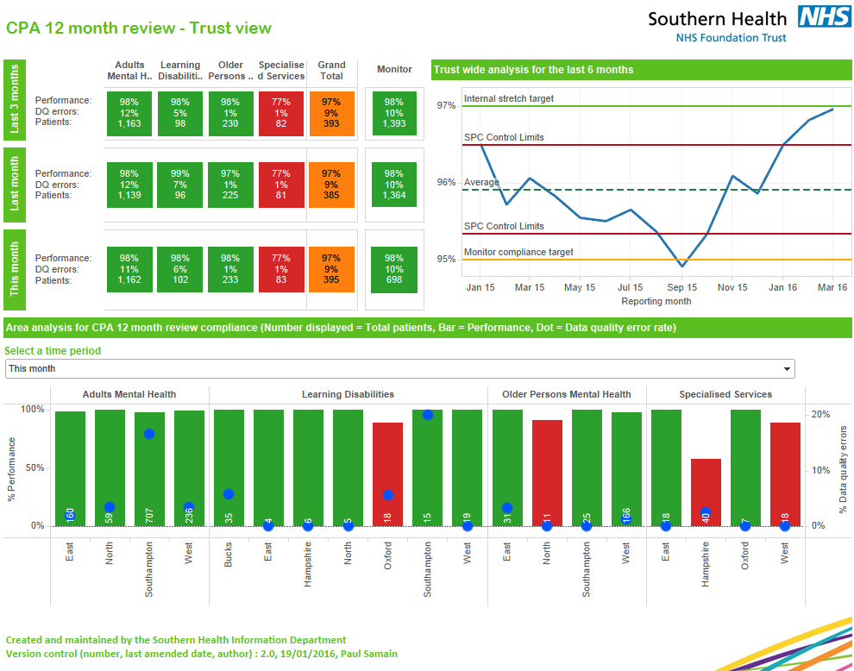
RAG colours use the approved colours
Swirls in the corner with the fixed position and size set to fit all
Footer has agreed content, font, colour and alignment.
Parameter has title above the drop down with SHFT green colour applied to font using Arial 9, bold, left aligned.
SPC chart has control limits, and average with agreed colour and labels and targets provided.
Chart or table title with white font, Arial 9 bold and left align with background set to SHFT green and size of box set to minimum height.
Visualisation title set to Arial rounded MT Bold, size 14, colour SHFT green, left align.

