Tableau User Guide
A guide for users of how to use Tableau

Created April 2017
Southern Health NHS Foundation Trust Information Department
analystteam@southernhealth.nhs.uk

Version Control
Version Author Description Date
1.0 Simon Beaumont User Guide created 22nd April 2017

Contents

1. An introduction to Tableau 2
1.1 What is Tableau? 2
1.2 Who can access Tableau? 2
1.3 Are there different levels of access? 2
1.4 How do I register for a Tableau account? 2
1.5 How do I access Tableau? 2
2. The Tableau homepage and searching for visualisations 3
2.1 Projects, Workbooks and Views 3
2.2 What projects are available in Tableau? 4
2.3 Searching for visualisations 4
2.4 Adding a visualisation as a favourite and filtering visualisations 5
2.5 Setting your custom homepage 5
3. Using visualisations 6
3.1 How to access visualisations 6
3.2 Using filters 6
3.3 Saving custom filters 7
3.4 Subscribing to visualisations 9
3.5 Exporting to PDF or as an image 10
3.6 Exporting to Excel 11
4. How to access further support and assistance 12
4.1 Tableau Walk In Surgeries 12
4.2 Tableau Lync at Lunch 12
4.3 Information Team training sessions 12
4.4 Who to contact with further questions or requests for new visualisations 12

1. An introduction to Tableau

1.1 What is Tableau?
Tableau is the Trust’s reporting tool that processes corporate and clinical data, with most data being updated on a daily basis. You can use Tableau to view data across the organisation, comparing divisions, areas and teams and drilling down to patient and staff level.

1.2 Who can access Tableau?
Every member of staff within the Trust can have access Tableau; there is no limitation to the number of users who can register for an account.

1.3 Are there different levels of access?
Yes; every Tableau user can view visualisations that compare teams and clinicians and provide patient level validation lists using the Trust’s internal Patient ID. The small number of visualisations that contain patient forename, surname or NHS Number are limited to clinician access only.

1.4 How do I register for a Tableau account?
To register for a Tableau account you should email the Southern Health NHS Foundation Trust Information Team via analystteam@southernhealth.nhs.uk. When requesting an account you should provide details of:
Your Forename and Surname
Your Network log in
Your Email address
The Team you work for and whether you are a clinician or not
Your request for a new Tableau account will be processed by the Southern Health NHS Foundation Trust Information Team within 48 working hours and you will be notified by email when your account has been activated.

1.5 How do I access Tableau?
Once your account has been activated you can access to Tableau in 2 ways
1. Typing in the web address to Internet Explorer | 2. Clicking on ‘Tableau’ in your favourites
Open Internet Explorer  In the web address type http://xxx-xxx-xxx-xxx | 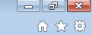Open Internet Explorer  Click on Favourites (star icon)  Click the SHFT folder  Click Tableau
Tableau top tip
If you click on either of the above methods and you receive a Tableau log on page asking for your username and password this will be because you are yet to be registered on Tableau.

2. The Tableau homepage and searching for visualisations

2.1 Projects, Workbooks and Views
Tableau is structured using Projects, Workbooks and Views.
What is a project?
A project is a term for where sets of visualisations are placed, with projects being based upon themes of data (i.e. clinical data, HR data, governance data). They are the equivalent of a folder in Windows. By clicking on a project you will gain access to all the visualisations within the project.

What is a Workbook?
A workbook is a collection of visualisations (views) relating to a specific topic, the equivalent of an Excel workbook. For example a trust wide waiting times workbook will consist of many different waiting times visualisations.

What is a view (visualisation)?
Views are the individual Tableau visualisations that you will click on to view data and analysis.

When you first log in to Tableau you will be presented with a screen that lists all of the Projects available to you. You can either click in an individual Project, such as ‘Clinical data’ to view the visualisations available to you in that Project or you can click on ‘Workbooks’ or ‘Views’ to view all Workbooks and Views across all the different Projects within Tableau.

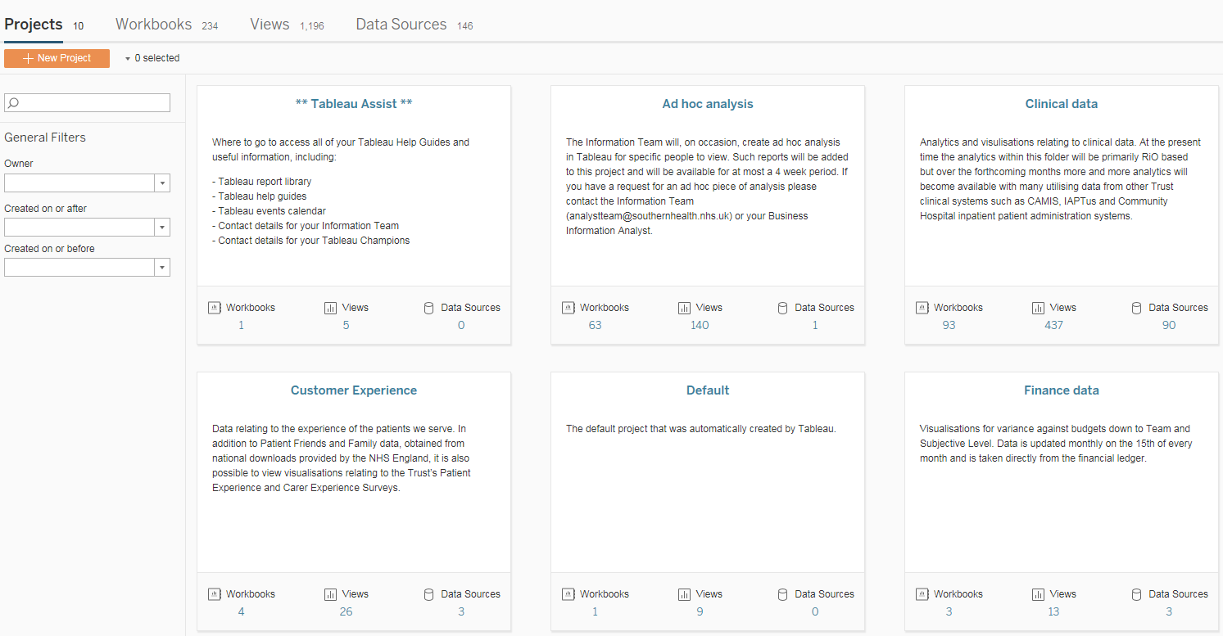

2.2 What projects are available in Tableau?
Within Tableau there are a number of projects available to you, each based on an individual theme of data:
Clinical data | HR data | Governance data
Visualisations relating to our clinical data; RiO, CaMIS, Quit4Life etc. | Visualisations relating to ESR and LEaD data; sickness, vacancies etc. | Visualisations relating to Ulysses; incidents, SIRIs, complaints etc.
Finance data | Customer experience data | **Tableau Assist**
Visualisations relating to our Finance data | Visualisations relating to the data collected via our patient experience surveys | Where to find your Tableau support material, report library, Tableau support diary and help guides.

2.3 Searching for visualisations
There are a number of different ways to search for visualisations within Tableau, all of which can be completed using the ‘General Filters’ options on the left of your screen.
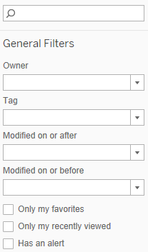
Favourites
You can mark a visualisation as one of your favourites and then tick this option to only view these visualisations.

Tags
Every Tableau visualisation has a number of pre-defined ‘Tags’ added by the Information Team. By selecting the tag relevant to your role or service you can limit the visualisations to only those you require to see.

The search bar
The search bar allows you to type in any key word and Tableau will return all visualisations that have that word in the title. For example ‘Waiting Times’ or ‘CPA’ would be key words that return a number of visualisations.

2.4 Adding a visualisation as a favourite and filtering visualisations
Tableau allows you to mark a visualisation as a favourite and then quickly find those visualisations at any point in time.
Tableau top tip
A Tableau top tip one page guide exists for saving your favourites, a summary of the steps is provided below, or access http://information.southernhealth.nhs.uk/tableau to download the top tip guide.
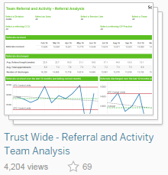
Making a report one of your favourites
When viewing the available reports click on the star icon of a report to identify it as one of your favourites; the star will then turn gold.

To remove the report from your favourites simply click on the star again and it will turn white.

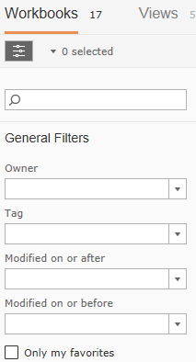
Viewing your favourites
To view your favourite reports either click the star icon in the black banner at the top of Tableau or tick the “Only my favourites” option in general filters, having gone into one of the Tableau projects (i.e. Clinical data).

2.5 Setting your custom homepage
Within Tableau it is possible to set a custom homepage that results in Tableau loading up only the content relevant to your service each time you access Tableau server.
Tableau top tip
A Tableau top tip one page guide exists for setting your homepage, a summary of the steps is provided below, or access the Tableau Assist project to download the top tip guide.

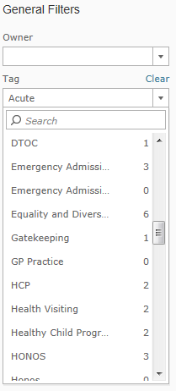
Select a tag
Every Tableau visualisation has a number of tags applied that help you understand what the visualisation is reporting against. These tags list the Divisions and Services applicable to a visualisation and the system the visualisation is based upon (i.e. RiO, CAMIS etc).
1

To select a tag click the ‘Tag’ drop down within the General Filters section on the left of the screen and either type the tag you wish to search for or scroll down the list of tags and click the relevant tag.

Having clicked on a tag all of the visualisations relevant to that tag will be displayed; when any new content is added Tableau will automatically load any new visualisations that have your selected tag applied to it.

Setting this view as your homepage
Click on your user profile
At the top right of your Tableau screen you will see your name alongside a drop down arrow. Click on the drop down arrow to access your user profile options.

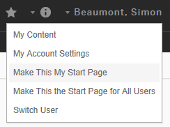
Make this my start page
Having applied the tag to the required project click on the drop down and select ‘Make this my start page’.

From now on every time you load up Tableau you will automatically be taken to the project you selected and your tag will be applied, with any new content relevant to you automatically loaded.

Once in Tableau should you need to access a different project simply click the ‘Home’ option and use Tableau as normal to navigate between project and visualisations.

3. Using visualisations

3.1 How to access visualisations
To access Tableau’s visualisations either click into a Project and then select the Workbook you wish to view or click the Views options at the top of your Tableau homepage.

3.2 Using filters
Every Tableau visualisation will provide you with filters that enable you to change the data being presented to you within the visualisation. Each visualisation will have a different set of filters, depending on what the visualisation is displaying, in general the most common filters relate to divisional hierarchy (Division, Area, Service Line, Locality and Team) and the time period you wish to view the visualisation for (Last x years, months, weeks or days).

Multiple select filters
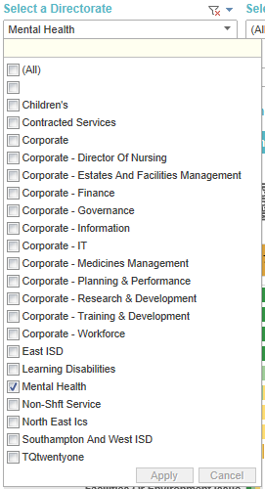
To change a filter click on the drop down you require changing. If the filter is a multiple selection drop down (identified by square tick boxes next to each option) you can un-tick and tick the required options. If an ‘All’ function exists this will tick and un-tick all options when selected. For most multiple selection drop down filters an ‘Apply’ button will also be available at the bottom of the available list; your selections will not be applied until the ‘Apply’ button is clicked.

Single select filters
Other filters such as single select drop downs only require you to click your required options without the need to click the ‘Apply’ button.
Date filters
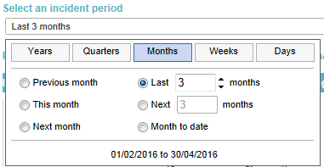
Tableau allows you to select the time period upon which the visualisation is based. When clicking on a date filter you are able to specify the date period based upon Years, Quarters, Months, Weeks and Days. Having selected your preferred option you can then click the ‘Previous’, ‘Current’, ‘Last x’ or period to date, for example the previous month, current month, last 2 months or month to date.

3.3 Saving custom filters
One of the most important features of Tableau is the ability for filters to be saved, allowing you to set the filters as your default; Tableau will then load the filter options each time you access the visualisation in the future.
Tableau top tip
A Tableau top tip guide exists for saving custom filters, a summary of the steps is provided below, or access the Tableau Assist project to download the top tip guide.

Apply the filters you wish to save
Click on the filter and apply your selections
As described in section 3.2 click on the multiple select, single select or date filter and apply your selections.
Save your selections
Create a custom view
Click on the ‘View’ option in the top right of your visualisation.
Naming your custom view and setting it as your default
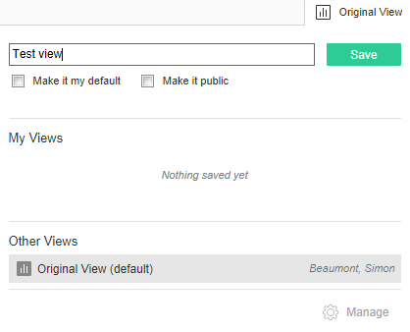
Having applied your selection, you are then able to save your filters and apply it as ‘your default’. Firstly name your filters with a name relevant to you for that visualisation. If you wish to make the filters your default view, click the ‘Make it my default’ option. This will ensure Tableau loads your saved filter every time you open the visualisation. Do not tick the ‘Make it public’ view; by doing this you will be sharing your view with all other Tableau users. Finally click ‘Save’ to store your Tableau view.

What to do if you did not make your view as your default
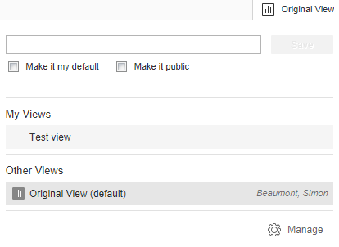
Many Tableau users will have responsibility for multiple clinical teams and as such you may have saved your filters for future use but you do not wish it to be your default. In this instance you can apply any one of your saved filters when accessing a visualisation. Click on the view button and select your required view from the list of options listed under ‘My Views’.

Managing your views
If you need to delete any existing saved filters click the view button and then click the ‘Manage’ option. Within the ‘My views’ section a number of icons will now appear next to each of your saved filters. The first ‘pen’ option allows you to rename the saved filter, the second ‘bin’ option allows you to delete the saved filter and the third ‘eye’ option allows you to make the view private or public. Please always ensure your saved filters have a line through the eye, symbolising your view is ‘private’. It is not possible to amend the options applied in a saved filter, instead you must delete the saved filter and save a new filter with your amended filters.
Warning : Always check if you have a saved filter applied to your visualisation
When viewing a visualisation it is easy to forget if you have a saved filter applied; this may result in you misinterpreting your data and as such making incorrect decisions. Please always check the ‘view’ option of a visualisation to check if you have a saved filter applied. It is easy to remove a saved filter, click on the view button and apply the ‘Original view’ option.

3.4 Subscribing to visualisations
Tableau allows you to subscribe to visualisations, allowing you to receive tailored content directly into your Southern Health inbox on a daily, weekly or monthly basis. Subscriptions are available to all Tableau users and for the majority of visualisations.
Tableau top tip
A Tableau top tip guide exists for subscriptions, a summary of the steps is provided below, or access the Tableau Assist project to download the top tip guide.

Applying your saved filters
Click on the filter and apply your selections
As described in section 3.2 click on the multiple select, single select or date filter and apply your selections.
Create a custom view
Click on the ‘View’ option in the top right of your visualisation.
Naming your custom view and setting it as your default
Having applied your selection, you are then able to save your filters and apply it as ‘your default’. Firstly name your filters with a name relevant to you for that visualisation. If you wish to make the filters your default view, click the ‘Make it my default’ option. This will ensure Tableau loads your saved filter every time you open the visualisation. Do not tick the ‘Make it public’ view; by doing this you will be sharing your view with all other Tableau users. Finally click ‘Save’ to store your Tableau view.

Setting your subscription
Click on the subscription icon
The subscription icon is in the top right of the visualisation.
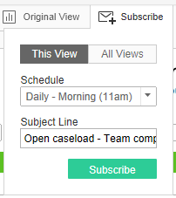
Apply your preferred subscription
You can subscribe to an individual view or all views within the workbook (all the tabs along the top of the workbook you have open). In most instances you will probably wish to subscribe to ‘This View’. A number of difference schedules have been created for you, select your preferred frequency, enter a subject line for the email and click ‘Subscribe’.
Cancelling a subscription
If you need to cancel a subscription click on your name in the top right of the screen and select ‘My Account Settings’. The screen will then show your account details, click on the ‘Subscriptions’ options, tick the subscription you wish to cancel and then click the drop down labelled ‘1 selected’ and select ‘Delete’.

3.5 Exporting to PDF or as an image
Any Tableau visualisation can be exported to PDF or exported as an image.
Tableau top tip
A Tableau top tip guide exists for exporting to PDF or as an image, a summary of the steps is provided below, or access the Tableau Assist project to download the top tip guide.

Open the visualisation you wish to export
Click on the ‘Download’ option
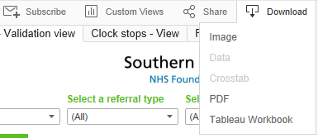
At the top right of your Tableau visualisation you will see a number of options, the far right of which is ‘Download’. Click on this option.
Choose your preferred option
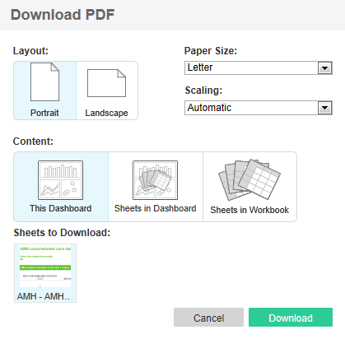
To export a visualisation as a PDF click on the PDF option, alternatively to export as an image click on the image option.
Choose your formatting options (PDF option)
Tableau will then prompt you to select a number of formatting options. Ensure you select Landscape layout, Letter paper size and Automatic scaling. Within the ‘Content’ setting ensure ‘This dashboard’ is highlighted. Click Download. If you selected to export as an image you will be taken straight to a pop up asking you to click Download.
Open or save your exported PDF or image
Once the export is complete Tableau will prompt you to open or save your exported PDF or image. If exporting as an image you can open the image within Paint and select a specific chart or table to import into other documents such as performance narratives or presentations (this step can take up to 20 seconds to complete).

3.6 Exporting to Excel
When Tableau displays a table of data it is possible to export this data to Excel. This will then allow you to manipulate the data in Excel using filters, however please note, once exported, the exported data within Excel will not then automatically refresh on a daily basis.
Tableau top tip
A Tableau top tip guide exists for exporting to Excel, a summary of the steps is provided below, or access the Tableau Assist project to download the top tip guide.

Open the visualisation you wish to export and activate the Table
Apply any filters to the visualisation that are required
Prior to exporting the data to Excel apply any filters that you require for the visualisation to ensure you do not export more data than you require.
Click on any part of the Table to be exported
Tableau needs to know which Table you wish to export. To activate a table click on any aspect of the data within the Tablea so that part of the Table is higlighted blue.
Export the data to Excel
Click on the Download Menu and select ‘Data’
At the top right of your Tableau visualisation you will see a number of options, the far right of which is ‘Download’. Click on this option.
From the available options click ‘Data. Please note if you have not highlighted a table as described in the previous step this option will not be available.
Click on ‘Download’ when prompted and then Open when the data has successfully exported, your data will now be available for you to use in Excel.

4. How to access further support and assistance

4.1 Tableau Walk In Surgeries
The Information Team are committed to regularly holding Walk in Surgeries that are available to anyone within the Trust to attend and ask specific questions of an Analyst. The Walk in Surgeries occur every month and are based at a range of locations across the Trust. For a full list of forthcoming Walk in Surgeries please access the Tableau Assist project.

4.2 Tableau Lync at Lunch
An alternative method of support occurs, virtually, every fortnight, lasting for 30 minutes and known as ‘Lync at Lunch’. These virtual meetings utilise Microsoft Lync and are specific to a division with each fortnight’s meeting being allocated to a different division. Participants can join via an online invitation sent by the Information Team and can ask questions of their Analyst, viewing the solution on screen.

4.3 Information Team training sessions
You are also able to request training from the Information Team and an Analyst will visit you and your team at a time convenient for you all. To arrange such a training session please contact your dedicated Analyst or email analystteam@southernhealth.nhs.uk.

4.4 Who to contact with further questions or requests for new visualisations
Should you have any further questions relating to Tableau, requests for new visualisations or feedback about your experience of using Tableau please contact the Information Team:
Email analystteam@southernhealth.nhs.uk
Telephone 023 80 874181

