Tableau top tip
Setting your Tableau homepage

Within Tableau it is possible to set a custom homepage that results in Tableau loading up only the content relevant to your service each time you access Tableau server.

Applying a tag
Click on Workbooks from your home page
From the Tableau homepage click on the ‘Workbooks’ option rather than ‘Projects’.

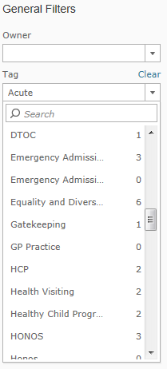
Select a tag
Every Tableau visualisation has a number of tags applied that help you understand what the visualisation is reporting against. These tags list the Divisions and Services applicable to a visualisation and the system the visualisation is based upon (i.e. RiO, CAMIS etc).

To select a tag click the ‘Tag’ drop down within the General Filters section on the left of the screen and either type the tag you wish to search for or scroll down the list of tags and click the relevant tag.

Having clicked on a tag all of the visualisations relevant to that tag will be displayed; when any new content is added Tableau will automatically load any new visualisations that have your selected tag applied to it.
Setting this view as your homepage
Click on your user profile
At the top right of your Tableau screen you will see your name alongside a drop down arrow. Click on the drop down arrow to access your user profile options.

Make this my start page
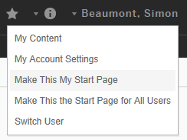
Having applied the tag to the required project click on the drop down and select ‘Make this my start page’.

From now on every time you load up Tableau you will automatically be taken to the project you selected and your tag will be applied, with any new content relevant to you automatically loaded.

Once in Tableau should you need to access additional content simply click the ‘Home’ option and use Tableau as normal to navigate between project and visualisations.

