Tableau top tip
Saving filters

All Southern Health Tableau reports include options that allow you to filter data within the report based on a number of pre-defined fields. For example changing a division the report is looking at or the reporting period being analysed.

We recognise that should you work in a specific team or division there is a high probability that you will regularly being applying these filters to the same report every time you open the report to view it. Tableau allows you to save these filter options so you can easily apply them to the report next time you view it.

Step 1: Selecting your filter options
Open the report you wish to save filters for
Apply your required filters to the report

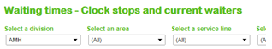

Step 2: Saving your filter options
Click on Original View
Enter a name for your customer view
Click “Make it my default” for Tableau to load it every time, un-tick “Make it public”, click “Save”

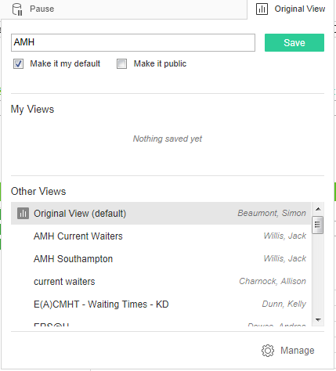

Step 3: Applying your custom view
If you made the view your default it will load automatically every time. To load a view manually, click “Original view” and then click the name of the required view.

